**Agriculture Website**

1. **Service-based**
2. **Requirement Analysis:**  
   **-** Understanding the needs and preferences of the farmers, agricultural professionals, agribusinesses, researchers, policymakers, and agricultural enthusiasts.  
   - Market prices and agricultural commodities trading  
   - Agricultural education and training materials
3. **Target Audience:**  
   - Small-scale and large-scale farmers are a primary target audience for agriculture apps.  
   - Wholesale business vendors  
   - Government Agencies and NGOs
4. **Project Timeline**
5. **Color Palette:**  
     
   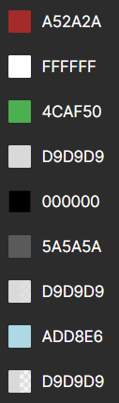
6. **Fonts:**  
     
   - Company Heading: ANTIQUA  
   - Section Headings/Commodities Name: Georgia Pro  
   - Commodities Description/Offers Description: CALIBRI/INTER  
     
   reference: fonts.google.com
7. **Images:**  
     
   - Vectors: Logo icon  
   - Rasters: All Commodities images, Background image
8. **Screen Size:**  
     
   - 1900px x 1080px (10px margin on each side)
9. **Primary Device & Browser:**  
     
   -Desktops/Laptops (phones used by farmers are mainly dial pads mobiles on which sites aren't accessible)  
   -Google Chrome/Firefox
10. **Frameworks:**  
      
    **HTML5/CSS3**
11. **Mockup:**  
      
    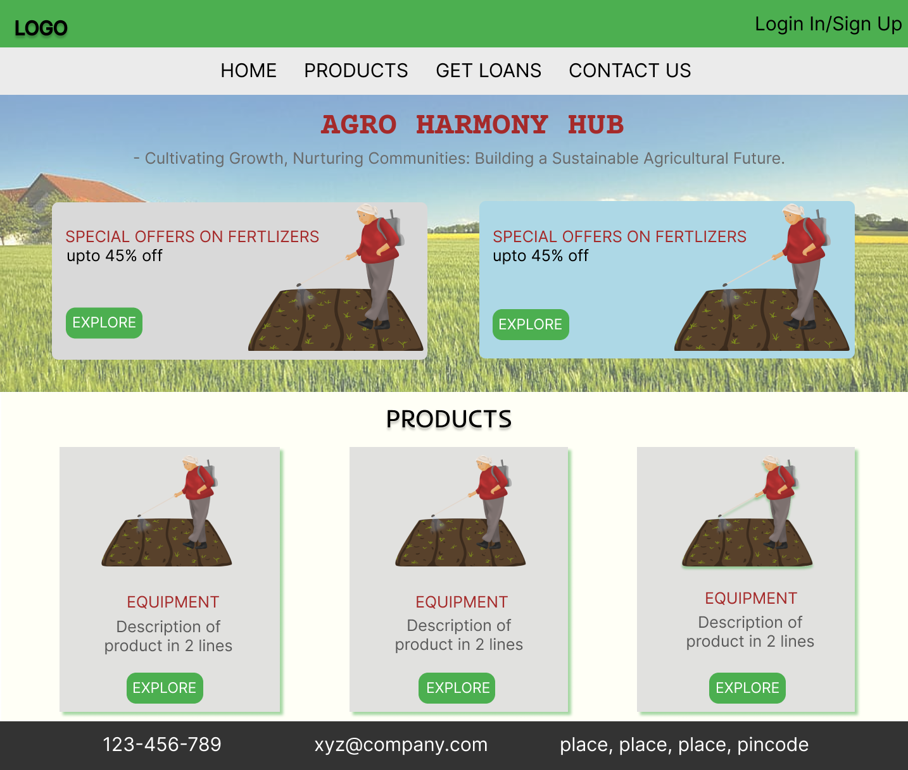
12. Hosted Link:  
      
    <https://aryanshankar.github.io/AGRO-HARMONY-HUB-Design/>

1. References:  
     
   - https://muffingroup.com/blog/agriculture-websites/